2022 World Food Prize Laureate Award Ceremony

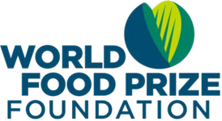
Directions: To celebrate World Food Day, please view the provided
link to the 2022 World Food Prize Laureate Award Ceremony and
provide your best responses!

Question 1: Why did Norman Borlaug win the Nobel Peace Prize?

Possible Answer: He utilized his knowledge of agriculture to help countries
feed their own people and avoid starvation. He integrated different streams of agricultural research including genetics, plant pathology, entomology, and soil science to develop new varieties of high-yielding crops. He was also successful in convincing political leaders around the world into allowing these new innovations to be utilized to feed their populations.

Question 2: What is the name of the person who won the World Food Prize this year? What is their area of focus?
Answer: Dr. Cynthia Rosenzweig, Senior Research Scientist and head of the Climate Impacts Group at the Goddard Institute for Space Studies (GISS)

Question 3: What impact has the 2022 World Food Prize Laureate had on agriculture? Why did they win the World Food Prize?
Possible Answer: Dr. Cynthia Rosenzweig of the United States will receive the 2022 World Food Prize for her seminal contributions to understanding and predicting the impacts of the interaction between climate and food systems. Through designing and leading rigorous, collaborative observational and modeling research, she provided the evidence used by thousands of decision-makers in more than 90 countries to both mitigate and adapt to climate change in local, national and global food systems.
For more information on Dr. Cynthia Rosenzweig, visit the World Food Prize Foundation website:
https://www.worldfoodprize.org/en/laureates/2022_rosenzweig/

Question 4: Why do you think it is important to celebrate agricultural researchers with the World Food Prize?
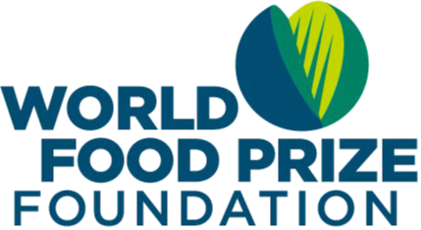
Possible Answer: It is important to elevate the work of agricultural scientists to educate the world on the importance of agriculture.

Remember, you can be part of the solution to solving world hunger! Engage the World Food Prize Global Youth Team on social media at @TheNextNorm

Additionally, follow along with the Global Teach Ag Network team at @GlobalTeachAg on all platforms!

