2022 World Food Prize Laureate Award Ceremony

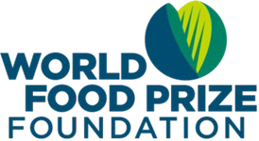
Directions: To celebrate World Food Day, please view the provided
link to the 2022 World Food Prize Laureate Award Ceremony and
provide your best responses!

Question 1: Why did Norman Borlaug win the Nobel Peace Prize?

Question 2: What is the name of the person who won the World Food Prize this year? What is their area of focus?

Question 3: What impact has the 2022 World Food Prize Laureate had on agriculture? Why did they win the World Food Prize?

Question 4: Why do you think it is important to celebrate agricultural researchers with the World Food Prize?

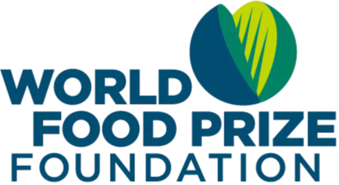
Remember, you can be part of the solution to solving world hunger! Engage the World Food Prize Global Youth Team on social media at @TheNextNorm

Additionally, follow along with the Global Teach Ag Network team at @GlobalTeachAg on all platforms!

