2020 World Food Prize Laureate Award Ceremony
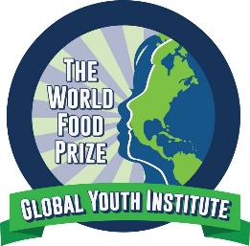
Directions: To celebrate World Food Day, please view the provided link to the 2020 World Food Prize Laureate Award Ceremony and provide your best responses!
Question 1: What is the name of the person who won the World Food Prize this year? What is his area of focus?
Answer: Dr. Rattan Lal, The Ohio State University, soil science
Question 2: Why did Norman Borlaug win the Nobel Peace Prize?
Possible Answer: He utilized his knowledge of agriculture to help countries feed their own people and avoid starvation. He integrated different streams of agricultural research including genetics, plant pathology, entomology, and soil science in order to develop new varieties of high-yielding crops. He was also successful in convincing political leaders around the world into allowing these new innovations to be utilized to feed their populations.
Question 3: What impact has Dr. Lal had on agriculture? Why did he win the World Food Prize?
Possible Answer: Dr. Lal has a soil-focused approach to agriculture that increases food production while also conserving natural resource and mitigates climate change. He has helped over 500 million farmers around the world with his techniques. Find more information about Dr. Lal here: https://www.worldfoodprize.org/en/laureates/2020_lal/
Question 4: Why do you think it is important to celebrate agricultural researchers with the World Food Prize?
Possible Answer: It is important to elevate the work of agricultural scientists in order to educate the world on the importance of agriculture.
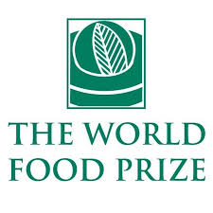
Remember, you can be part of the solution to solving world hunger!
Engage the World Food Prize Global Youth Team on Social Media at @TheNextNorm

